

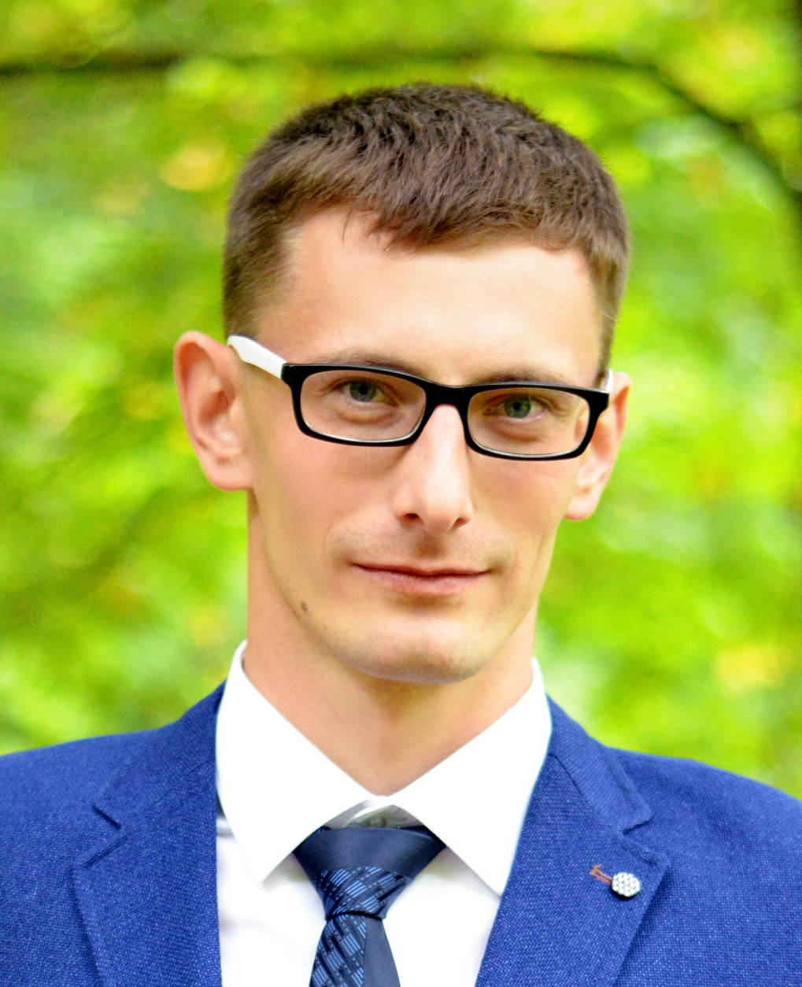

**Aliaksandr Pahranouski**

Junior Frontend Developer

**Phone: +375 29 520-22-94**

## Email: pograncheg@gmail.com

**Skype: pogran-a**

## LinkedIn: [Aliaksandr Pahranouski](https://www.linkedin.com/in/aliaksandr-pahranouski-475775252/)

**Github:** [**pograncheg**](https://github.com/pograncheg/)

# Summary

I’m beginner Frontend Developer. Successfully completed courses in “Website development with HTML, CSS and JavaScript” and “Web application development with JavaScript” at Educational Center for Programming and High Tech IT-Academy. Currently learning the React framework and TypeScript.

I easily connect with new people, have a good sense of humour, listening and communication skills. I can control myself and always friendly. I am willing to take on difficult tasks and learn something new to complete them. Successfully completed task is pleasure for me.

I’m married and have a son. I like to meet my friends and play football in my free time.

# Skills

**English: Pre-Intermediate (A2)**

* Internet technologies: HTML, CSS, HTTP (GET, POST).
* Programming Languages: JavaScript.
* Databases: SQL queries.
* Experience of: Jira.

# Education

**June 2022 – September 2022 - IT-Academy**

**Course: WEB APPLICATION DEVELOPMENT WITH JAVASCRIPT**

**February 2022 – May 2022 - IT-Academy**

**Course: WEBSITE DEVELOPMENT WITH HTML, CSS & JAVASCRIPT**

**2008-2013 – Brest State Technical University**

**Specialization: Automated Data Processing Systems**

# Work Experience

***July 2013 - September 2016 -, Bureau of Passportization of the Population, Brest***

**Used tools:** SQL.

***September 2016 - Present – Software specialist, Regional Center for Legal Information, Brest***

**Used tools:** Jira.